**WIPRO ASSIGNMENT WORK DAY -1**

**USER ID – 28986**

**NAME – ALANKRIT PRAKASH SHUKLA**

**TOPIC – IT – INFRA INTRODUCTION**

* NETWORK MEANING - A **computer network** is a group of **two or more computers** and **other devices** (like printers, routers, or switches) that are **connected** to **share resources** and **communicate** with each other.

**Main Purposes of a Computer Network:**

* **Resource Sharing** – Share files, printers, and internet connection.
* **Communication** – Send emails, chat, or video calls.
* **Data Access** – Access databases and applications across systems.
* **Centralized Management** – Control security, updates, and backups from a central point.
* **DIFFERENT NETWORKING TERMS-**

1. **Intranet**  
   A private network used within an organization. It allows employees to share information and collaborate securely.  
   ➤ Example: Company internal web portals.
   1. **Internet**  
      A global network that connects millions of computers worldwide, enabling sharing of information and communication.
2. **Domain**  
   A group of computers and devices on a network that are administered as a unit with common rules. Also refers to domain names (e.g., **google.com**) used to identify websites.
3. **Email (Electronic Mail)**  
   A system for sending messages and files electronically over a network, especially the Internet.
4. **FTP (File Transfer Protocol)**  
   A protocol used to transfer files between computers over the Internet or a network.
5. **HTTP (HyperText Transfer Protocol)**  
   A protocol used for accessing and transferring web pages on the World Wide Web.
6. **ISP (Internet Service Provider)**  
   A company that provides individuals or organizations access to the Internet.  
   ➤ Example: Airtel, Jio, Comcast.
7. **Workgroup**  
   A peer-to-peer network model in Windows where computers share files and printers without a centralized server.
8. **NIC (Network Interface Card)**  
   A hardware component that connects a computer to a network. It can be wired (Ethernet) or wireless (Wi-Fi).
9. **Crossover Cable (Cross Cable)**  
   A type of Ethernet cable used to connect **two similar devices** directly, like PC-to-PC, without a switch or router.
10. **Straight-Through Cable**  
    An Ethernet cable used to connect **different types of devices**, like a PC to a switch or router.
11. **Wired Router**  
    A network device that connects different networks and directs data using cables (Ethernet). Often includes LAN ports.
12. **Wireless Router**  
    A router that provides internet and network access over **Wi-Fi** in addition to wired connections.
13. **Switch**  
    A networking device that connects multiple devices in a **LAN** and forwards data based on **MAC addresses**.
14. **UTP (Unshielded Twisted Pair)**  
    A common type of network cabling with twisted wire pairs, used in most Ethernet networks.  
    ➤ Cheaper, less resistant to interference.
15. **STP (Shielded Twisted Pair)**  
    Similar to UTP but has a **metal shield** to reduce electromagnetic interference.  
    ➤ Used in environments with high interference.
16. **Optical Fiber**  
    A high-speed transmission medium that uses **light** to carry data through glass or plastic fibers.  
    ➤ Very fast and reliable, used in backbone networks and long distances.
17. **RJ45 Connector**  
    A standard connector used on Ethernet cables for networking. It connects devices like PCs, switches, and routers.

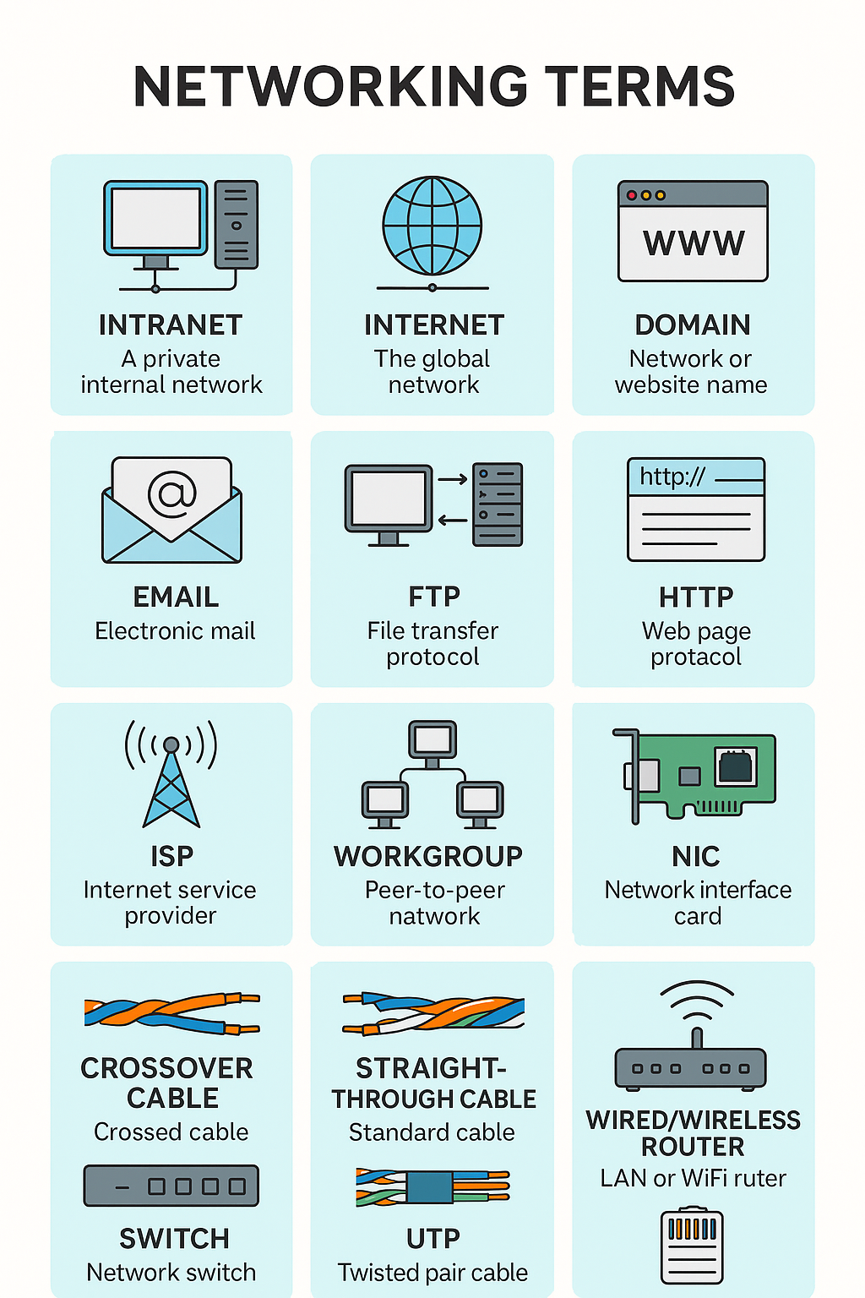

* **NETWORKING DEVICES AND VARIOUS TYPES –**

🔹 IP (Internet Protocol)

* A set of rules for addressing and routing data on a network.
* Ensures data reaches the correct destination.

🔹 TCP (Transmission Control Protocol)

* Ensures reliable delivery of data between devices.
* Breaks data into packets and reassembles them at the destination.

🔹 Types of IP Addresses

1. IPv4 – 32-bit address (e.g., 192.168.1.1)
2. IPv6 – 128-bit address for modern networks (e.g., 2001:0db8:85a3::8a2e:0370:7334)
3. Static IP – Manually assigned, doesn't change
4. Dynamic IP – Automatically assigned by DHCP server
5. Private IP – Used within a local network (e.g., 192.168.x.x)
6. Public IP – Used to identify a device on the Internet

🔹 Computer Servers

* High-performance computers that provide services (like file storage, web hosting, or databases) to other computers.

🔹 Networking Devices & Their Purpose

| Device | Purpose |
| --- | --- |
| Router | Routes data between different networks (LAN to WAN) |
| Switch | Connects devices in a LAN and forwards data using MAC addresses |
| Hub | Broadcasts data to all devices (less efficient) |
| Bridge | Connects and filters traffic between two network segments |
| Repeater | Boosts weak network signals to extend range |
| Gateway | Connects two different networks using different protocols |
| Modem | Converts analog signals to digital and vice versa (for internet access) |
| Access Point | Extends wireless coverage in a network |
| NIC | Network Interface Card – allows a device to connect to a network |
| Firewall | Monitors and controls incoming/outgoing traffic for security |

🔹 Types of Routers

1. Wired Router – Connects via Ethernet cables
2. Wireless Router – Connects wirelessly (Wi-Fi)
3. Core Router – High-capacity router for backbone networks
4. Edge Router – Sits at the boundary of a network and connects to external networks

🔹 Types of Modem

1. DSL Modem – Uses telephone lines
2. Cable Modem – Uses coaxial cable (TV lines)
3. Fiber Modem – Uses fiber-optic lines (high-speed)
4. Wireless Modem – Uses cellular networks (4G/5G)

🔹 OSI Model (Open Systems Interconnection) – 7 Layers

| Layer No. | Name | Function |
| --- | --- | --- |
| 7 | Application | User interaction (e.g., browser) |
| 6 | Presentation | Data format, encryption, compression |
| 5 | Session | Establishes, maintains sessions |
| 4 | Transport | Reliable data transfer (TCP/UDP) |
| 3 | Network | Routing and addressing (IP) |
| 2 | Data Link | MAC addresses, switches |
| 1 | Physical | Cables, NIC, signals |

🔹 Firewall Protection

* Software or hardware security system that monitors and filters network traffic.
* Prevents unauthorized access, blocks malicious traffic, and ensures network integrity.

